**4CS401: Cryptography and Network Security**

**B.Tech. (CSE) – I [ 2022-23 ]**

**Assignment No - 6**

**Data Encryption Standard**

**Title: Data encryption standard**

**Aim: To Demonstrate Data encryption standard**

**Theory:**

**DES is a block cipher and encrypts data in blocks of size of 64 bits  each, which means 64 bits of plain text go as the input to DES, which produces 64 bits of ciphertext. The same algorithm and key are used for encryption and decryption, with minor differences. The key length is 56 bits**

**Procedure:**

1. **In the first step, the 64-bit plain text block is handed over to an initial Permutation (IP) function.**
2. **The initial permutation is performed on plain text.**
3. **Next, the initial permutation (IP) produces two halves of the permuted block; saying Left Plain Text (LPT) and Right Plain Text (RPT).**
4. **Now each LPT and RPT go through 16 rounds of the encryption process.**
5. **In the end, LPT and RPT are rejoined and a Final Permutation (FP) is performed on the combined block**
6. **The result of this process produces 64-bit ciphertext.**

**Virtual Lab:**

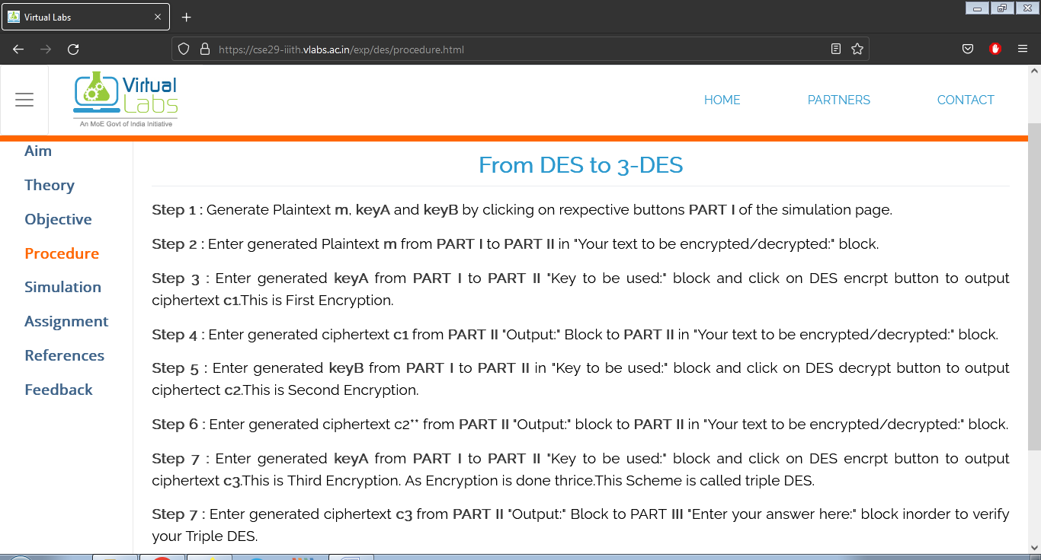

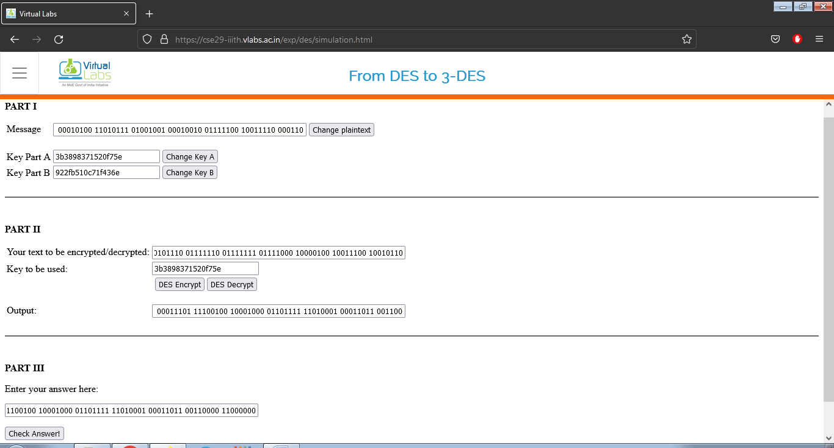

**Code:**

**#include <bits/stdc++.h>**

**#define ll long long**

**#define ul unsigned long long**

**#define pb emplace_back**

**#define po pop_back**

**#define vi vector<ll>**

**#define vii vector<vector<ll>>**

**using namespace std;**

**void file(){**

**ios_base::sync_with_stdio(false);**

**cin.tie(NULL);}**

**ll M = 1e9 + 7;**

**vector<int> ipConvertArr(64);**

**string hex2bin(string s)**

**{**

**// hexadecimal to binary conversion**

**unordered_map<char, string> mp;**

**mp['0'] = "0000";**

**mp['1'] = "0001";**

**mp['2'] = "0010";**

**mp['3'] = "0011";**

**mp['4'] = "0100";**

**mp['5'] = "0101";**

**mp['6'] = "0110";**

**mp['7'] = "0111";**

**mp['8'] = "1000";**

**mp['9'] = "1001";**

**mp['A'] = "1010";**

**mp['B'] = "1011";**

**mp['C'] = "1100";**

**mp['D'] = "1101";**

**mp['E'] = "1110";**

**mp['F'] = "1111";**

**string bin = "";**

**for (int i = 0; i < s.size(); i++) {**

**bin += mp[s[i]];**

**}**

**return bin;**

**}**

**void Permutearr(){**

**for(int i=0;i<64;i++){**

**ipConvertArr[i] =((56+i)%64);**

**}**

**}**

**string bin2hex(string s)**

**{**

**// binary to hexadecimal conversion**

**unordered_map<string, string> mp;**

**mp["0000"] = "0";**

**mp["0001"] = "1";**

**mp["0010"] = "2";**

**mp["0011"] = "3";**

**mp["0100"] = "4";**

**mp["0101"] = "5";**

**mp["0110"] = "6";**

**mp["0111"] = "7";**

**mp["1000"] = "8";**

**mp["1001"] = "9";**

**mp["1010"] = "A";**

**mp["1011"] = "B";**

**mp["1100"] = "C";**

**mp["1101"] = "D";**

**mp["1110"] = "E";**

**mp["1111"] = "F";**

**string hex = "";**

**for (int i = 0; i < s.length(); i += 4) {**

**string ch = "";**

**ch += s[i];**

**ch += s[i + 1];**

**ch += s[i + 2];**

**ch += s[i + 3];**

**hex += mp[ch];**

**}**

**return hex;**

**}**

**string permute(string k, int* arr, int n)**

**{**

**string per = "";**

**for (int i = 0; i < n; i++) {**

**per += k[arr[i] - 1];**

**}**

**return per;**

**}**

**string xor_(string a, string b)**

**{**

**string ans = "";**

**for (int i = 0; i < a.size(); i++) {**

**if (a[i] == b[i]) {**

**ans += "0";**

**}**

**else {**

**ans += "1";**

**}**

**}**

**return ans;**

**}**

**string shift_left(string k, int shifts)**

**{**

**string s = "";**

**for (int i = 0; i < shifts; i++) {**

**for (int j = 1; j < 28; j++) {**

**s += k[j];**

**}**

**s += k[0];**

**k = s;**

**s = "";**

**}**

**return k;**

**}**

**string convertKey(string key){**

**string keyBin = hex2bin(key);**

**cout<<keyBin;**

**//parity bit drop table**

**int arr[56]**

**= { 57, 49, 41, 33, 25, 17, 9,  1,  58, 50, 42, 34,**

**26, 18, 10, 2,  59, 51, 43, 35, 27, 19, 11, 3,**

**60, 52, 44, 36, 63, 55, 47, 39, 31, 23, 15, 7,**

**62, 54, 46, 38, 30, 22, 14, 6,  61, 53, 45, 37,**

**29, 21, 13, 5,  28, 20, 12, 4 };**

**string key56 = "";**

**//cout<<keyBin.size();**

**for (int i = 0; i < 56; i++) {**

**key56 += keyBin[arr[i] - 1];**

**}**

**cout<<"\nThe 56 bit key is : "<<key56;**

**return key56;**

**}**

**string initialPermutation(string input){**

**string ip = "";**

**for(auto x:input)**

**ip += bitset<8>(x).to_string();**

**string final_ip="";**

**// cout<<ip.size();**

**for(int i=63;i>=0;i--){**

**// cout<<ipConvertArr[i]<<" ";**

**final_ip += ip[ipConvertArr[i]];**

**}**

**cout<<"Output after initial Permutation : "<<final_ip<<"\n";**

**return final_ip;**

**}**

**string finalPermutation(string ans){**

**string final_ip="";**

**// cout<<ip.size();**

**for(int i=0;i<64;i++){**

**// cout<<ipConvertArr[i]<<" ";**

**final_ip += ans[ipConvertArr[i]];**

**}**

**cout<<"Output after initial Permutation : "<<final_ip<<"\n";**

**return final_ip;**

**}**

**string Encrypt(string input, vector<string> rkb, vector<string> rkh){**

**string res = initialPermutation(input);**

**// cout<<"Output after initial permutation: "<<res<<"\n";**

**string lp = res.substr(0,32);**

**string rp = res.substr(32);**

**cout<<"left half  = "<<lp<<"\n";**

**cout<<"right half = "<<rp<<"\n";**

**// Expansion D-box Table**

**int exp_d[48]**

**= { 32, 1,  2,  3,  4,  5,  4,  5,  6,  7,  8,  9,**

**8,  9,  10, 11, 12, 13, 12, 13, 14, 15, 16, 17,**

**16, 17, 18, 19, 20, 21, 20, 21, 22, 23, 24, 25,**

**24, 25, 26, 27, 28, 29, 28, 29, 30, 31, 32, 1 };**

**// S-box Table**

**int s[8][4][16] = {**

**{ 14, 4,  13, 1, 2,  15, 11, 8,  3,  10, 6,  12, 5,**

**9,  0,  7,  0, 15, 7,  4,  14, 2,  13, 1,  10, 6,**

**12, 11, 9,  5, 3,  8,  4,  1,  14, 8,  13, 6,  2,**

**11, 15, 12, 9, 7,  3,  10, 5,  0,  15, 12, 8,  2,**

**4,  9,  1,  7, 5,  11, 3,  14, 10, 0,  6,  13 },**

**{ 15, 1,  8,  14, 6,  11, 3, 4,  9,  7,  2,  13, 12,**

**0,  5,  10, 3,  13, 4,  7, 15, 2,  8,  14, 12, 0,**

**1,  10, 6,  9,  11, 5,  0, 14, 7,  11, 10, 4,  13,**

**1,  5,  8,  12, 6,  9,  3, 2,  15, 13, 8,  10, 1,**

**3,  15, 4,  2,  11, 6,  7, 12, 0,  5,  14, 9 },**

**{ 10, 0,  9,  14, 6,  3,  15, 5,  1,  13, 12,**

**7,  11, 4,  2,  8,  13, 7,  0,  9,  3,  4,**

**6,  10, 2,  8,  5,  14, 12, 11, 15, 1,  13,**

**6,  4,  9,  8,  15, 3,  0,  11, 1,  2,  12,**

**5,  10, 14, 7,  1,  10, 13, 0,  6,  9,  8,**

**7,  4,  15, 14, 3,  11, 5,  2,  12 },**

**{ 7,  13, 14, 3,  0,  6,  9,  10, 1,  2, 8,  5,  11,**

**12, 4,  15, 13, 8,  11, 5,  6,  15, 0, 3,  4,  7,**

**2,  12, 1,  10, 14, 9,  10, 6,  9,  0, 12, 11, 7,**

**13, 15, 1,  3,  14, 5,  2,  8,  4,  3, 15, 0,  6,**

**10, 1,  13, 8,  9,  4,  5,  11, 12, 7, 2,  14 },**

**{ 2,  12, 4, 1,  7,  10, 11, 6, 8,  5,  3,  15, 13,**

**0,  14, 9, 14, 11, 2,  12, 4, 7,  13, 1,  5,  0,**

**15, 10, 3, 9,  8,  6,  4,  2, 1,  11, 10, 13, 7,**

**8,  15, 9, 12, 5,  6,  3,  0, 14, 11, 8,  12, 7,**

**1,  14, 2, 13, 6,  15, 0,  9, 10, 4,  5,  3 },**

**{ 12, 1,  10, 15, 9,  2,  6,  8,  0,  13, 3, 4, 14,**

**7,  5,  11, 10, 15, 4,  2,  7,  12, 9,  5, 6, 1,**

**13, 14, 0,  11, 3,  8,  9,  14, 15, 5,  2, 8, 12,**

**3,  7,  0,  4,  10, 1,  13, 11, 6,  4,  3, 2, 12,**

**9,  5,  15, 10, 11, 14, 1,  7,  6,  0,  8, 13 },**

**{ 4,  11, 2,  14, 15, 0,  8, 13, 3,  12, 9,  7,  5,**

**10, 6,  1,  13, 0,  11, 7, 4,  9,  1,  10, 14, 3,**

**5,  12, 2,  15, 8,  6,  1, 4,  11, 13, 12, 3,  7,**

**14, 10, 15, 6,  8,  0,  5, 9,  2,  6,  11, 13, 8,**

**1,  4,  10, 7,  9,  5,  0, 15, 14, 2,  3,  12 },**

**{ 13, 2,  8, 4,  6,  15, 11, 1,  10, 9, 3, 14, 5,**

**0,  12, 7, 1,  15, 13, 8,  10, 3,  7, 4, 12, 5,**

**6,  11, 0, 14, 9,  2,  7,  11, 4,  1, 9, 12, 14,**

**2,  0,  6, 10, 13, 15, 3,  5,  8,  2, 1, 14, 7,**

**4,  10, 8, 13, 15, 12, 9,  0,  3,  5, 6, 11 }**

**};**

**// Straight Permutation Table**

**int per[32]**

**= { 16, 7, 20, 21, 29, 12, 28, 17, 1,  15, 23,**

**26, 5, 18, 31, 10, 2,  8,  24, 14, 32, 27,**

**3,  9, 19, 13, 30, 6,  22, 11, 4,  25 };**

**cout << endl;**

**for (int i = 0; i < 16; i++) {**

**// Expansion D-box**

**string right_expanded = permute(rp, exp_d, 48);**

**// XOR RoundKey[i] and right_expanded**

**string x = xor_(rkb[i], right_expanded);**

**// S-boxes**

**string op = "";**

**for (int i = 0; i < 8; i++) {**

**int row = 2 * int(x[i * 6] - '0')**

**+ int(x[i * 6 + 5] - '0');**

**int col = 8 * int(x[i * 6 + 1] - '0')**

**+ 4 * int(x[i * 6 + 2] - '0')**

**+ 2 * int(x[i * 6 + 3] - '0')**

**+ int(x[i * 6 + 4] - '0');**

**int val = s[i][row][col];**

**op += char(val / 8 + '0');**

**val = val % 8;**

**op += char(val / 4 + '0');**

**val = val % 4;**

**op += char(val / 2 + '0');**

**val = val % 2;**

**op += char(val + '0');**

**}**

**// Straight D-box**

**op = permute(op, per, 32);**

**// XOR left and op**

**x = xor_(op, lp);**

**lp = x;**

**// Swapper**

**if (i != 15) {**

**string temp = lp;**

**lp = rp;**

**rp=temp;**

**}**

**cout <<"Round " << i + 1 << " " << bin2hex(lp)**

**<<" " << bin2hex(rp) << " " << rkh[i]**

**<< endl;**

**}**

**// Combination**

**string combine = lp + rp;**

**return combine;**

**}**

**string Des(string input, string key64){**

**cout<<"Step 1 ---------------------------------------\n";**

**string key = convertKey(key64);**

**// cout<<cipherKey;**

**cout<<"\n Length of Cipher Key :"<<key.size()<<"\n";**

**// Number of bit shifts**

**cout<<"Step 2 ---------------------------------------\n";**

**int shift_table[16] = { 1, 1, 2, 2, 2, 2, 2, 2,**

**1, 2, 2, 2, 2, 2, 2, 1 };**

**// Key- Compression Table**

**int key_comp[48] = { 14, 17, 11, 24, 1,  5,  3,  28,**

**15, 6,  21, 10, 23, 19, 12, 4,**

**26, 8,  16, 7,  27, 20, 13, 2,**

**41, 52, 31, 37, 47, 55, 30, 40,**

**51, 45, 33, 48, 44, 49, 39, 56,**

**34, 53, 46, 42, 50, 36, 29, 32 };**

**//Split the Key**

**string leftKey = key.substr(0, 28);**

**string rightKey = key.substr(28, 28);**

**vector<string> rkb; // rkb for RoundKeys in binary**

**vector<string> rkh; // rk for RoundKeys in hexadecimal**

**for (int i = 0; i < 16; i++) {**

**// Shifting**

**leftKey = shift_left(leftKey, shift_table[i]);**

**rightKey = shift_left(rightKey, shift_table[i]);**

**// Combining**

**string combine = leftKey + rightKey;**

**int key_comp[48] = { 14, 17, 11, 24, 1,  5,  3,  28,**

**15, 6,  21, 10, 23, 19, 12, 4,**

**26, 8,  16, 7,  27, 20, 13, 2,**

**41, 52, 31, 37, 47, 55, 30, 40,**

**51, 45, 33, 48, 44, 49, 39, 56,**

**34, 53, 46, 42, 50, 36, 29, 32 };**

**// Key Compression**

**string RoundKey = permute(combine, key_comp, 48);**

**rkb.push_back(RoundKey);**

**rkh.push_back(bin2hex(RoundKey));**

**}**

**int idx=1;**

**cout<<"key for 16 rounds are :\n";**

**for(auto x:rkh){**

**cout<<"Key "<<idx<<": "<<x<<"\n";**

**idx++;**

**}**

**cout<<"DES Encryption ------------------------\n";**

**string ans =  Encrypt(input, rkb,rkh);**

**ans = finalPermutation(ans);**

**ans = bin2hex(ans);**

**cout<<"the CipherText is : ";**

**cout<<ans<<"\n";**

**cout << "\nDecryption\n\n";**

**reverse(rkb.begin(), rkb.end());**

**reverse(rkh.begin(), rkh.end());**

**string text = Encrypt(ans, rkb, rkh);**

**cout << "\nPlain Text: " << bin2hex(text) << endl;**

**return ans;**

**}**

**int main()**

**{   file();**

**string input;**

**string key;**

**// cout<<"Enter the Key in HEXADECIMAL:";**

**cin>>key;**

**cin>>input;**

**cout<<"Key :"<<key<<"\n";**

**cout<<"input : "<<input<<"\n";**

**Permutearr();**

**string ans = Des(input,key);**

**return 0;**

**}**

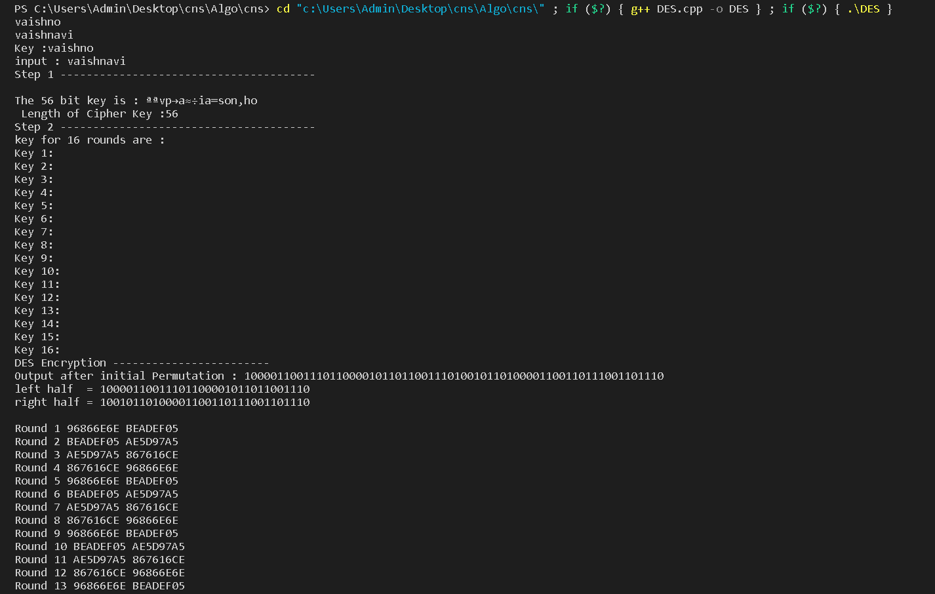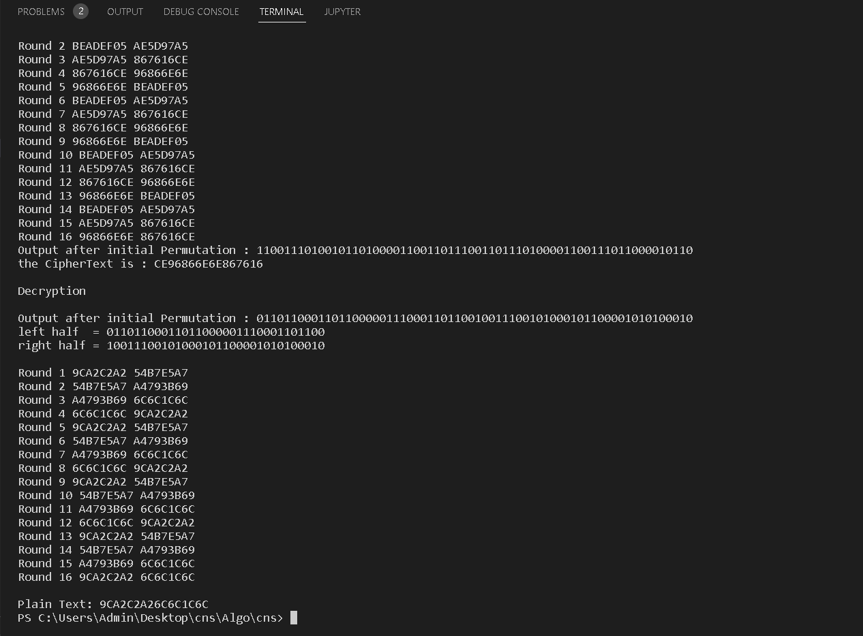

**Conclusion:**

**The DES satisfies both the desired properties of block cipher. These two properties make cipher very strong.**

1. **Avalanche effect − A small change in plaintext results in a great change in the ciphertext.**
2. **Completeness − Each bit of ciphertext depends on many bits of plaintext.**

**Data encryption standard (DES) has been found vulnerable to very powerful attacks and therefore, the popularity of DES has been found slightly on the decline**